**Assignment 6**

**Swapnil Kamate**

**11.**

**Answer:**

SELECT I.CUS_CODE,I.INV_NUMBER,I.INV_DATE,P.P_DESCRIPT,L.LINE_UNITS,L.LINE_PRICE

FROM LINE AS L

JOIN INVOICE AS I

ON L.INV_NUMBER = I.INV_NUMBER

JOIN PRODUCT AS P

ON P.P_CODE = L.P_CODE

ORDER BY CUS_CODE,INV_NUMBER,P_DESCRIPT

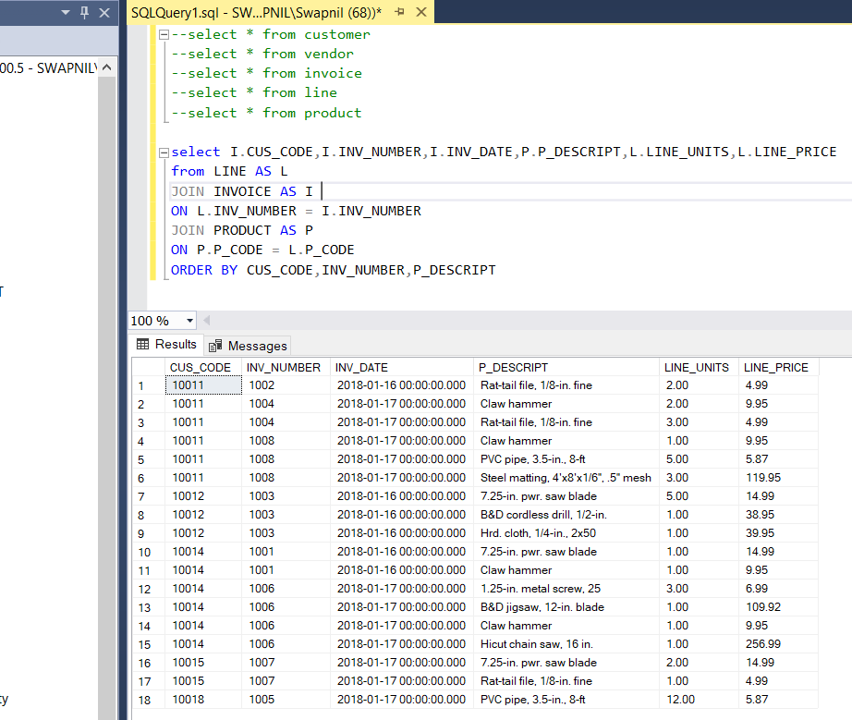

**12**

**Answer:**

SELECT I.CUS_CODE, I.INV_NUMBER, P.P_DESCRIPT, L.LINE_UNITS AS [Units Bought],

L.LINE_PRICE AS [Unit Price], (L.LINE_UNITS *L.LINE_PRICE) AS [Subtotal]

FROM LINE AS L

JOIN INVOICE AS I

ON L.INV_NUMBER = I.INV_NUMBER

JOIN PRODUCT AS P

ON P.P_CODE = L.P_CODE

ORDER BY CUS_CODE,INV_NUMBER,P_DESCRIPT

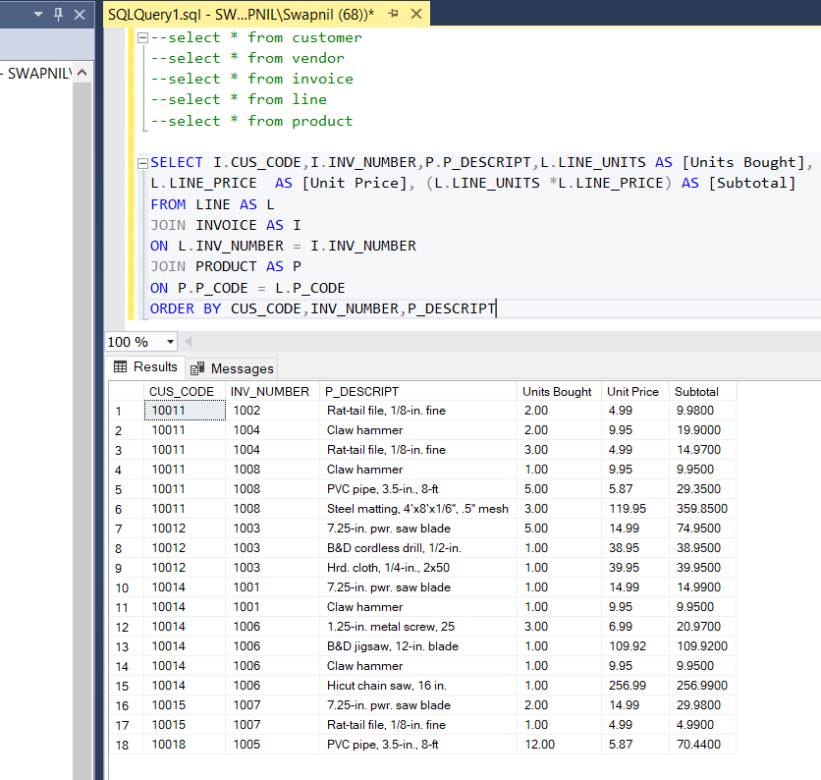

**13.**

**Answer:**

SELECT C.CUS_CODE, C.CUS_BALANCE, SUM((L.LINE_UNITS *L.LINE_PRICE) ) AS [Total Purchases]

FROM CUSTOMER AS C

JOIN INVOICE AS I

ON C.CUS_CODE = I.CUS_CODE

JOIN LINE AS L

ON I.INV_NUMBER = L.INV_NUMBER

GROUP BY C.CUS_CODE,C.CUS_BALANCE

ORDER BY CUS_CODE;

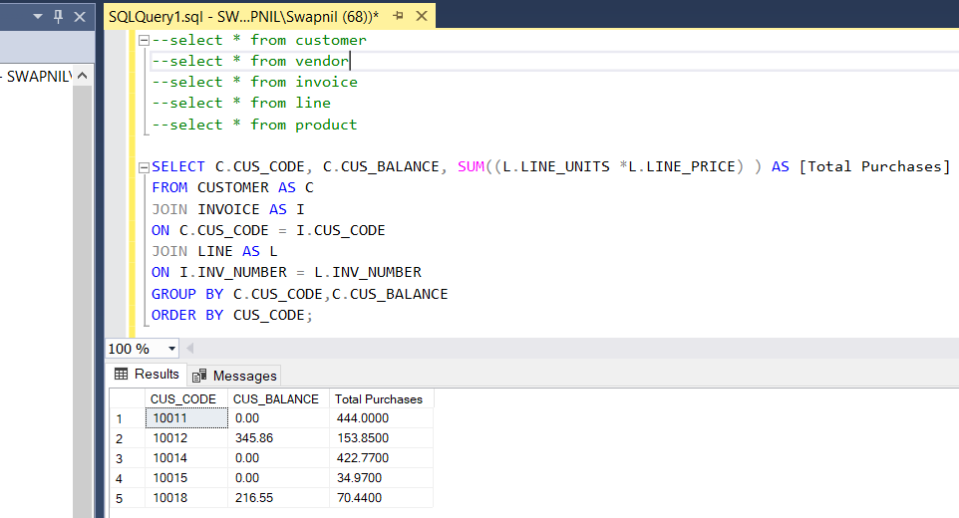

**14.**

**Answer:**

SELECT I.CUS_CODE, C.CUS_BALANCE, SUM((L.LINE_UNITS *L.LINE_PRICE) ) AS [Total Purchases],COUNT(I.CUS_CODE) AS [Number of Purchases]

FROM CUSTOMER AS C

JOIN INVOICE AS I

ON C.CUS_CODE = I.CUS_CODE

JOIN LINE AS L

ON I.INV_NUMBER = L.INV_NUMBER

GROUP BY I.CUS_CODE,C.CUS_BALANCE

ORDER BY CUS_CODE;

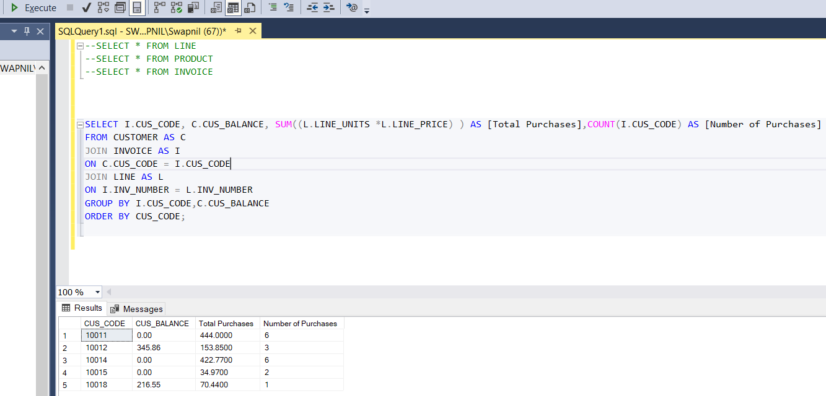

15.

Answer:

SELECT I.CUS_CODE, C.CUS_BALANCE, SUM((L.LINE_UNITS *L.LINE_PRICE) ) AS [Total Purchases],COUNT(I.CUS_CODE) AS [Number of Purchases],

AVG(L.LINE_UNITS *L.LINE_PRICE) AS [Average Purchase Amount]

FROM CUSTOMER AS C

JOIN INVOICE AS I

ON C.CUS_CODE = I.CUS_CODE

JOIN LINE AS L

ON I.INV_NUMBER = L.INV_NUMBER

GROUP BY I.CUS_CODE,C.CUS_BALANCE

ORDER BY CUS_CODE;

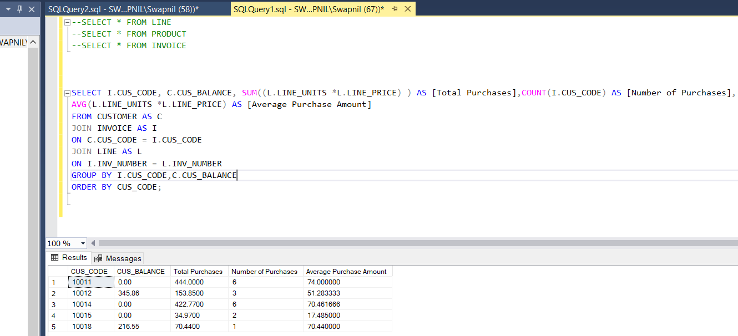

16.

Answer:

SELECT INV_NUMBER, SUM(LINE_UNITS * LINE_PRICE) AS [Invoice Total]

FROM LINE

GROUP BY INV_NUMBER

ORDER BY INV_NUMBER;

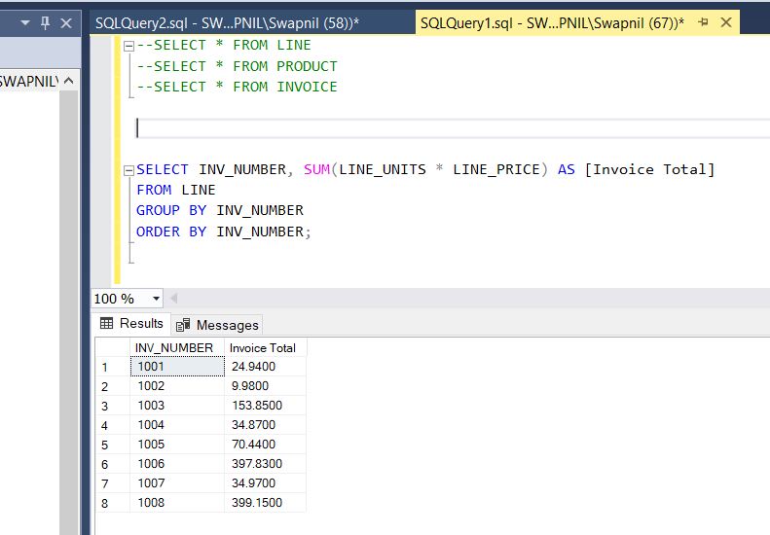

17.

Answer:

SELECT I.CUS_CODE, I.INV_NUMBER, SUM(L.LINE_UNITS * L.LINE_PRICE) AS [Invoice Total]

FROM INVOICE AS I

JOIN LINE AS L

ON I.INV_NUMBER = L.INV_NUMBER

GROUP BY I.CUS_CODE, I.INV_NUMBER

ORDER BY I.CUS_CODE, I.INV_NUMBER;

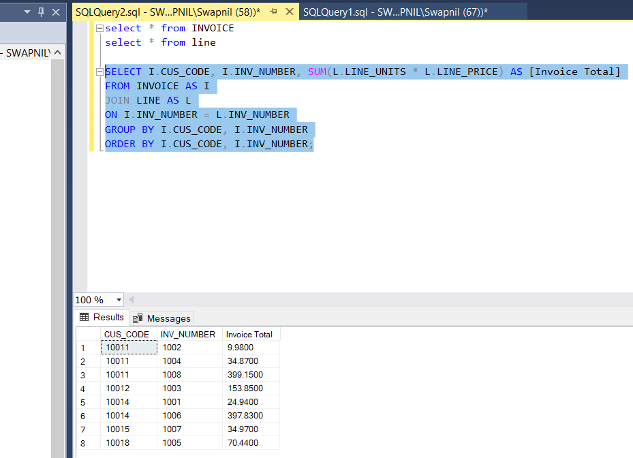

18.

Answer:

SELECT CUS_CODE,COUNT(INV_NUMBER) AS 'Number of Invoices',

SUM(INV_TOTAL) AS 'Total Customer Purchases'

FROM (SELECT CUS_CODE, LINE.INV_NUMBER AS INV_NUMBER,

SUM(LINE.LINE_UNITS*LINE.LINE_PRICE) AS INV_TOTAL

FROM INVOICE , LINE

WHERE INVOICE.INV_NUMBER = LINE.INV_NUMBER

GROUP BY CUS_CODE, LINE.INV_NUMBER) as sub

GROUP BY CUS_CODE ;

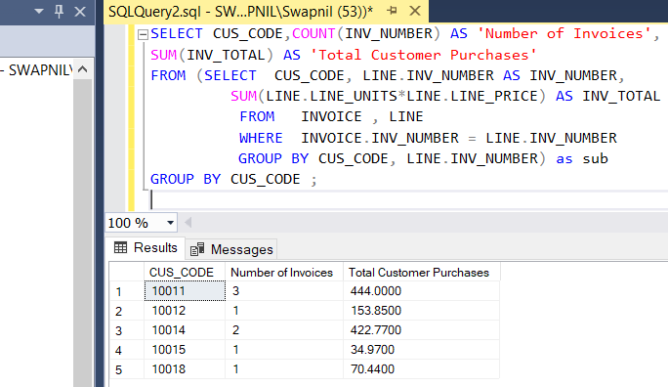

19.

Answer:

SELECT Sum(INV_NUMBER) AS 'Total Invoices',

Sum(TOT_CUS_PURCHASES) AS 'Total Sales',

MIN(TOT_CUS_PURCHASES) AS 'Minimum Customer Purchases',

MAX(TOT_CUS_PURCHASES) AS 'Maximum Customer Purchases',

AVG(TOT_CUS_PURCHASES) AS 'Average Customer Purchases'

FROM (SELECT CUS_CODE, COUNT(INV_NUMBER) AS INV_NUMBER, Sum(Invoice_Total) AS

TOT_CUS_PURCHASES

FROM (SELECT CUS_CODE, LINE.INV_NUMBER AS INV_NUMBER,

Sum(LINE.LINE_UNITS*LINE.LINE_PRICE) AS Invoice_Total

FROM INVOICE, LINE

WHERE INVOICE.INV_NUMBER = LINE.INV_NUMBER

GROUP BY CUS_CODE, LINE.INV_NUMBER) as sub

GROUP BY CUS_CODE

) AS sub;

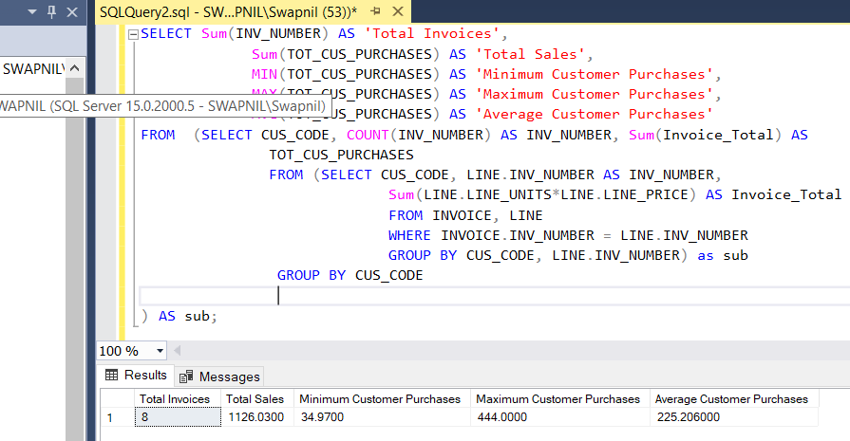

20.

Answer:

SELECT DISTINCT I.CUS_CODE, C.CUS_BALANCE

FROM INVOICE AS I

JOIN CUSTOMER AS C

ON I.CUS_CODE = C.CUS_CODE

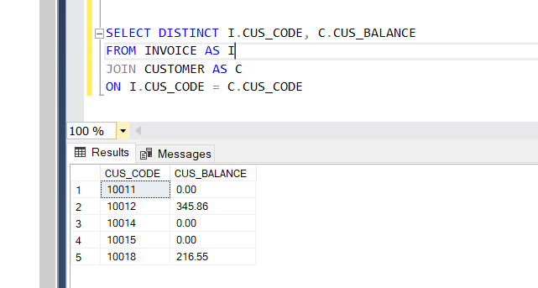

21.

Answer:

SELECT MIN(CUS_BALANCE) AS 'Minimum Balance',

MAX(CUS_BALANCE) AS 'Maximum Balance',

AVG(CUS_BALANCE) AS 'Average Balance'

FROM( SELECT CUS_CODE, CUS_BALANCE

FROM CUSTOMER

WHERE CUSTOMER.CUS_CODE IN (SELECT DISTINCT CUS_CODE FROM INVOICE )

ORDER BY CUS_CODE) as sub

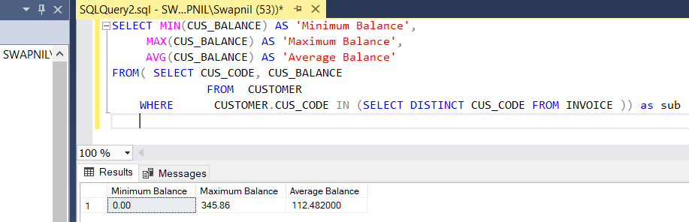

22.

Answer:

SELECT SUM(CUS_BALANCE) AS [Total Balances], MIN(CUS_BALANCE) AS [Minimum Balance] ,

MAX(CUS_BALANCE) AS [Maximum Balance], AVG(CUS_BALANCE) AS [Average Balance]

FROM CUSTOMER

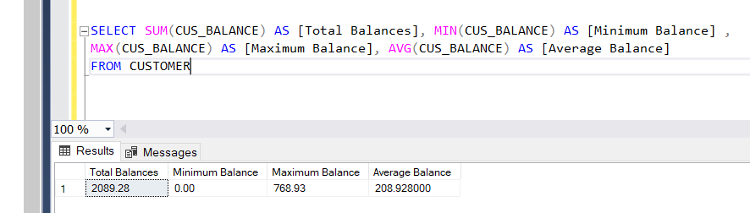

23.

Answer:

SELECT CUS_CODE , CUS_BALANCE

FROM CUSTOMER

WHERE CUSTOMER.CUS_CODE NOT IN (SELECT DISTINCT CUS_CODE FROM INVOICE)

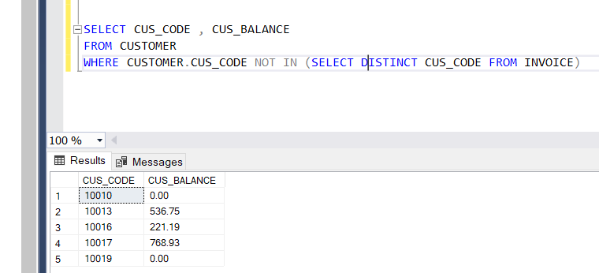

24.

Answer:

SELECT SUM(CUS_BALANCE) AS 'Total Balance',

MIN(CUS_BALANCE) AS 'Minimum Balance',

MAX(CUS_BALANCE) AS 'Maximum Balance',

AVG(CUS_BALANCE) AS 'Average Balance'

FROM (SELECT CUS_CODE, CUS_BALANCE

FROM CUSTOMER

WHERE CUSTOMER.CUS_CODE NOT IN (SELECT DISTINCT CUS_CODE FROM INVOICE)) as sub;

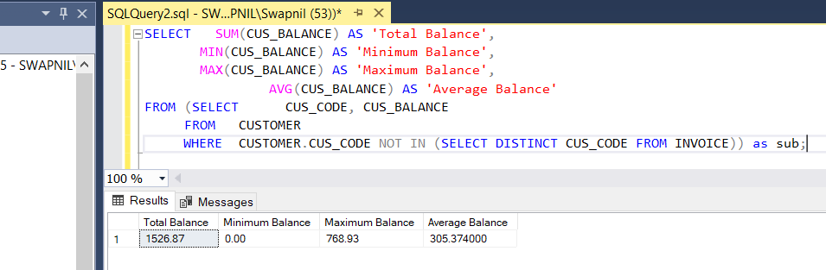

25.

Answer:

SELECT P_DESCRIPT,P_QOH,P_PRICE ,(P_QOH*P_PRICE) AS Subtotal

FROM PRODUCT

ORDER BY Subtotal DESC

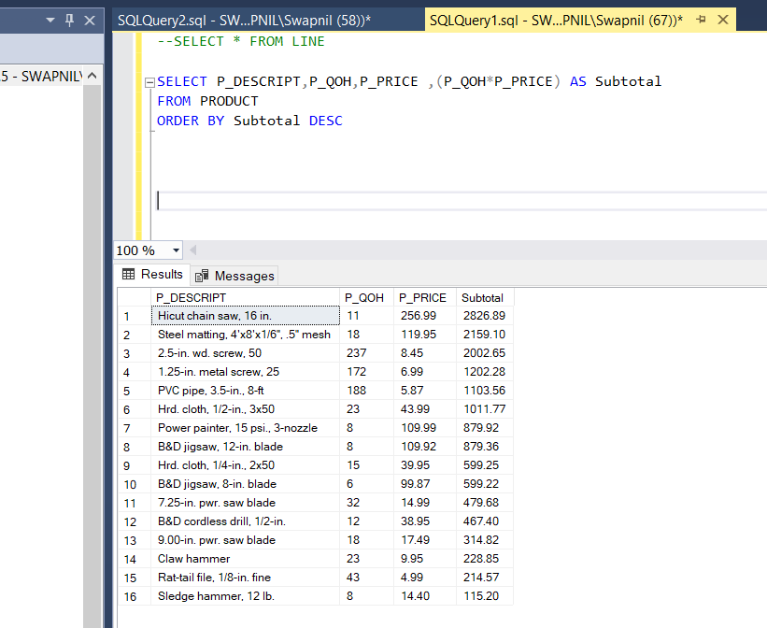

26.

Answer:

SELECT SUM(P_QOH*P_PRICE) AS [Total value of Inventory]

FROM PRODUCT

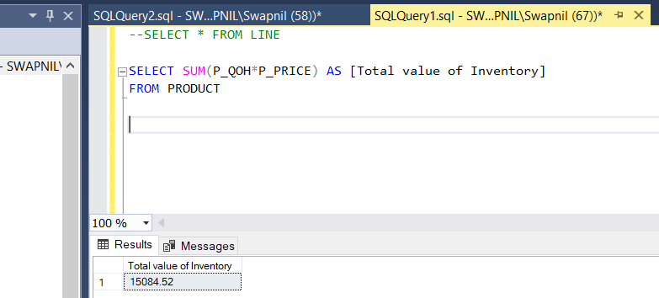

27.

Answer:

SELECT dept_name FROM lgdepartment

ORDER BY dept_name;

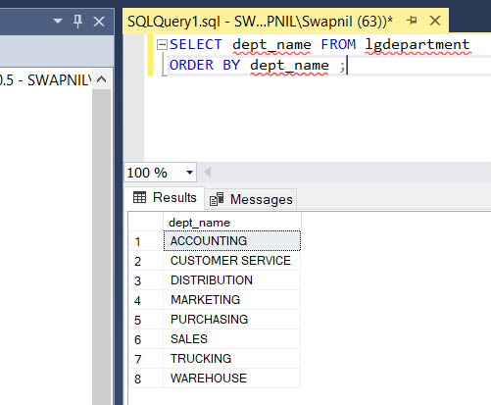

28.

Answer:

SELECT prod_sku,prod_descript, prod_type,prod_base,prod_category,prod_price

FROM LGPRODUCT

WHERE prod_base ='Water' AND prod_category ='Sealer';

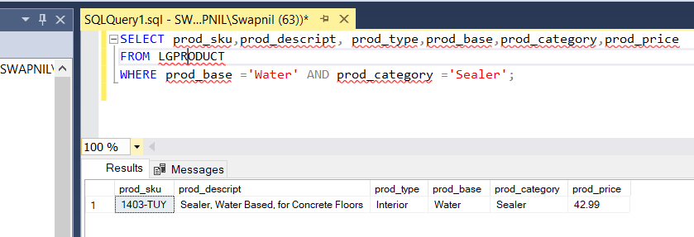

29.

Answer:

SELECT emp_fname,emp_lname,emp_email FROM lgemployee

WHERE emp_hiredate BETWEEN '2005-01-01' AND '2014-12-31'

ORDER BY emp_lname,emp_fname;

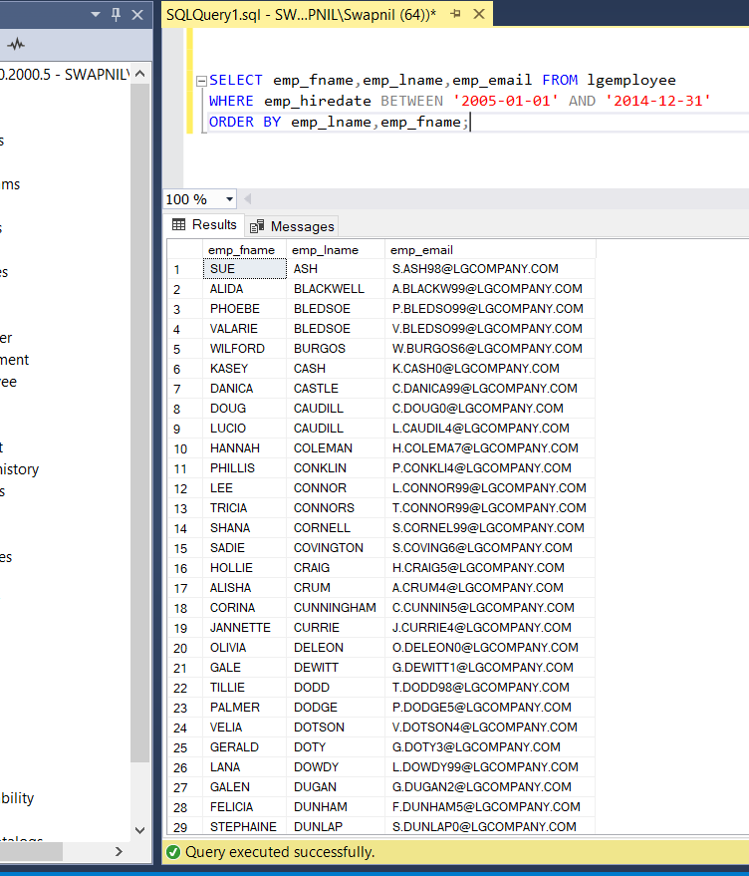

30.

Answer:

SELECT emp_fname,emp_lname,emp_phone,emp_title,dept_num FROM lgemployee

WHERE dept_num = 300 OR emp_title = 'CLERK I'

ORDER BY emp_lname,emp_fname;

